|  |  |
| --- | --- |
| Team Number : | apmcm2304366 |
| Problem Chosen : | C |

2023 APMCM summary sheet

Contents

(At the beginning of this text)

**5.1 Analyzing the main factors affecting the development of new energy electric vehicles in China**

**（1）Data collection**

We organize the collected data and set Year as an irrelevant variable, but changes in Year will affect the subsequent changes, so we keep Year. then we set New energy vehicle ownership (10,000 vehicles) and New Energy Vehicle Market Size (RMB billion) as dependent variables because our group believes that changes in these two variables can reflect changes in the development of new energy electric vehicles in China. Then we set Number of patent applications for new energy vehicles (items), Amount of subsidies for new energy vehicles (RMB billion), Total carbon emissions ( millions of tons), Lithium iron phosphate power battery installed capacity/GWh, Installed capacity of ternary battery/GWh, Weighted average price of new energy vehicles ($10,000), New energy vehicle market penetration (%) are set as independent variables, considering that they are the main factors affecting the change of the dependent variable.

Therefore, we design the statistical graph as shown below.

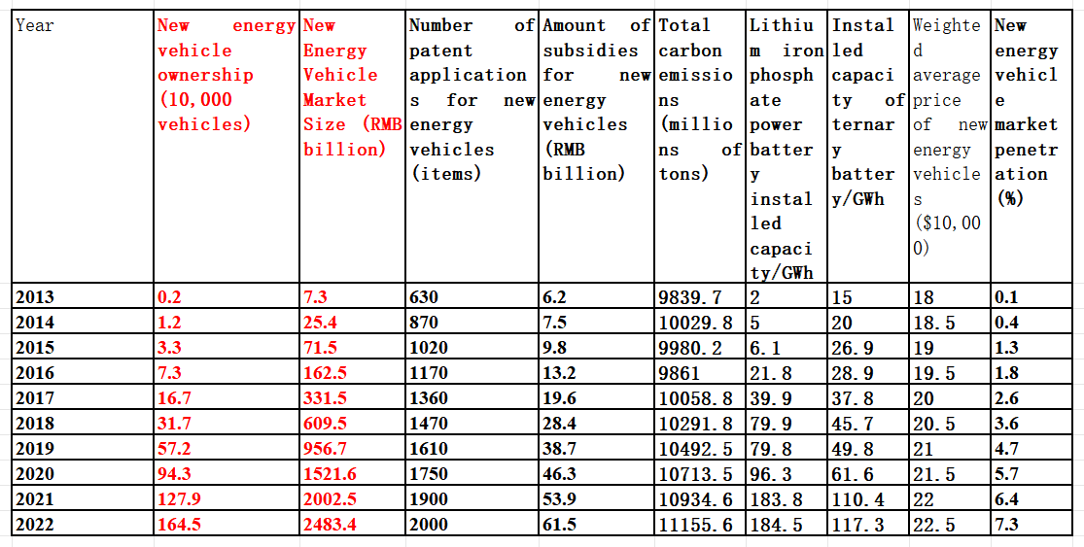

**Picture Statistical data on factors affecting the development of new energy vehicles**

According to the following correlation coefficient heatmap, it can be seen that when New energy vehicle ownership (10000 vehicles) and New Energy Vehicle Market Size (RMB bill) are used as dependent variables, their values are related to Year, Number of patient applications for new energy vehicles (items), Amount of subsidiaries for new energy vehicles (RMB bill), Total carbon emissions (miles of tons) Lithium iron phosphate power battery installed capacity/GWh, installed capacity of term battery/GWh, and weighted average price of new energy vehicles ($10000) are all related. And the correlation coefficients are relatively large (greater than 0.8 and mostly 0.95-1)

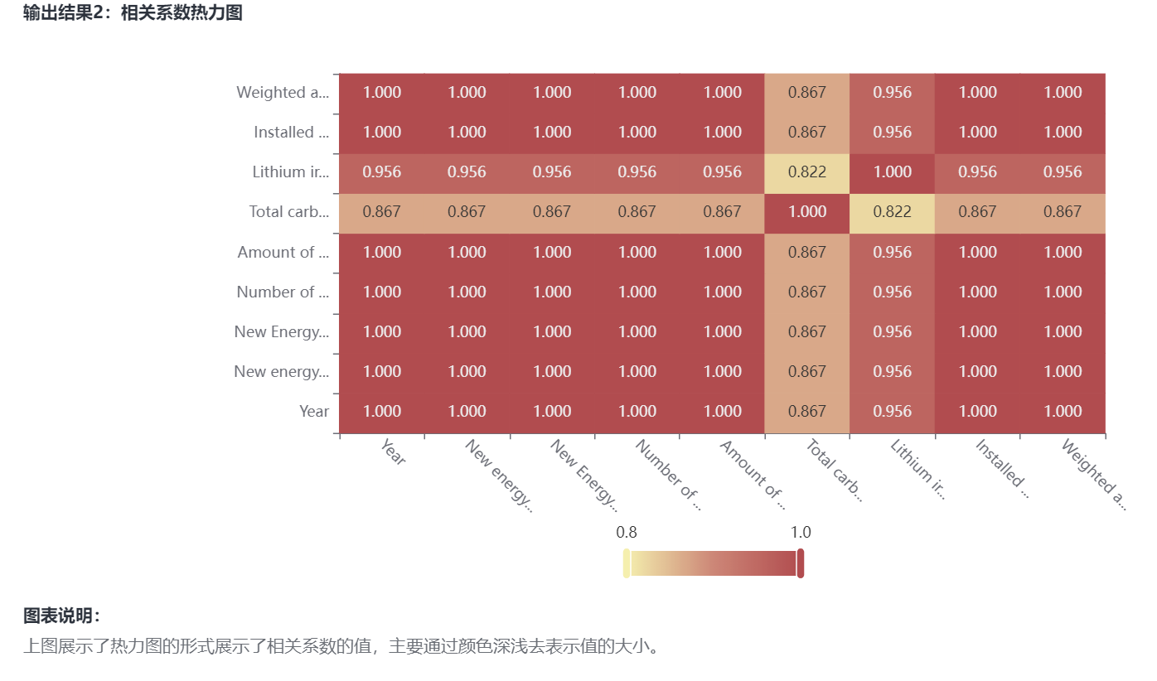

Picture Correlation coefficient heat map

1. **New energy vehicle ownership (10,000 vehicles) multiple regression curve**

According to the change of New energy vehicle ownership (10,000 vehicles) and its first-order difference curve over the years, it can be seen that New energy vehicle ownership (10,000 vehicles) shows an upward trend, so the factors in the multivariate regression curve of New energy vehicle ownership (10,000 vehicles) should generally show an upward trend after weighting. Therefore, the factors in the multiple regression curve of New energy vehicle ownership (10,000 vehicles) should be in an upward trend after weighting in general. And we can also know that the curve of New energy vehicle ownership (10,000 vehicles) is accelerating in general.

**Picture Vehicle ownership and its first-order difference curve vary with year**

The analysis of the results of the F-test shows that the P-value of significance is 0.001 * * *, which is significant at the level and rejects the null hypothesis of a regression coefficient of 0. Therefore, the model basically meets the requirements.

For the collinearity performance of variables, the VIF values of Year, Number of patent applications for new energy vehicles (items), Amount of subsidiaries for new energy vehicles (RMB bill), Total carbon emissions (miles of tons), Lithium iron phase power battery installed capacity/GWh, Installed capacity of term battery/GWh, Weighted average price of new energy vehicles ($10000) are greater than 10, There is a collinear relationship, so it is easy to remove the collinear independent variables or perform ridge regression or stepwise regression.

The formula of the model is as follows: y=-0.046-0.507 * Year -0.155 * Number of patient applications for new energy vehicles (items)+1.81 * Amount of subsidiaries for new energy vehicles (RMB bill)+0.028 * Total carbon emissions (miles of tons) -0.556 * Lithium iron phase power battery installed capacity/GWh+1.402 * Installed capacity of term battery/GWh+44.817 * Weighted average price of new energy vehicles ($10000).

This also confirms that the fit is very good.

**Table Table of results of linear regression analysis**

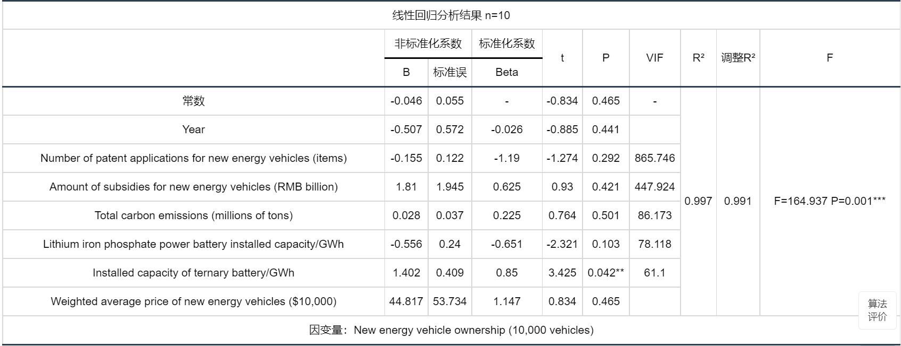

The following figure shows the independent variables X: {Year, Number of patient applications for new energy vehicles (items), Amount of subsidiaries for new energy vehicles (RMB bill), Total carbon emissions (miles of tons), Lithium iron phase power battery installed capacity/GWh, Installed capacity of term battery/GWh, Weighted average price of new energy vehicles ($10000)}; The relationship between the dependent variable Y: {New energy vehicle ownership (10000 vehicles)}

We order:

y=New energy vehicle ownership (10,000 vehicles)

*x*1=Year

*x*2=Number of patent applications for new energy vehicles (items)

*x*3=Amount of subsidies for new energy vehicles (RMB billion)

*x*4=Total carbon emissions (millions of tons)

*x*5=Lithium iron phosphate power battery installed capacity/GWh

*x*6=Installed capacity of ternary battery/GWh

*x*7=Weighted average price of new energy vehicles ($10,000)

According to the statistics listed above,we could get this function：

y=-0.046-0.507*x*1-0.155*x*2+1.81*x*3+0.028*x*4-0.556*x*5+1.402*x*6+44.817*x*7

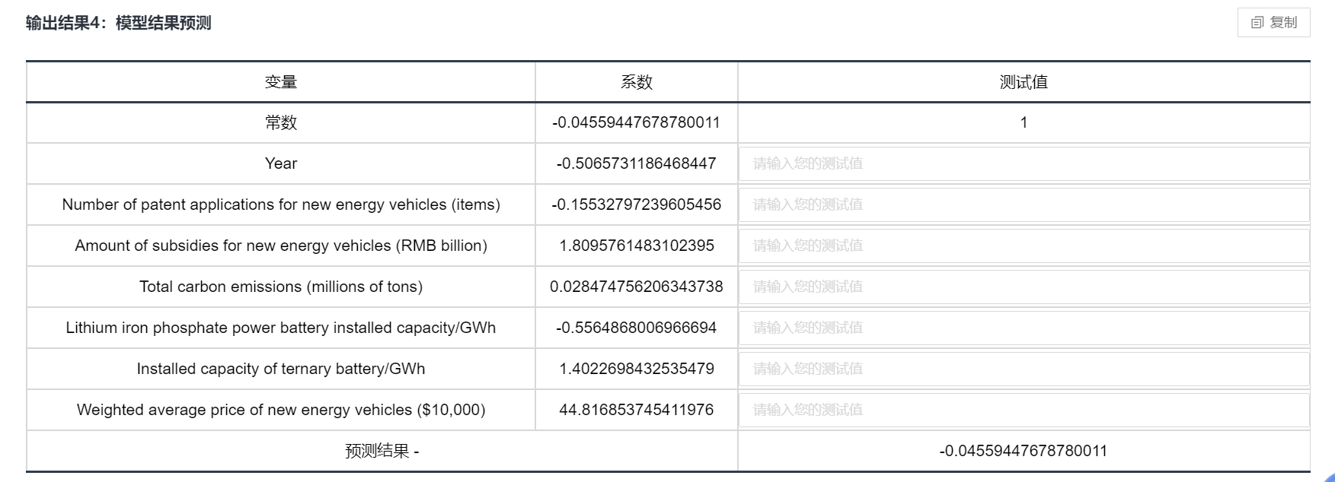

The following graph shows the raw data plot, model fitted values, and model predicted values for this model.

According to the graph, the fit is very good.

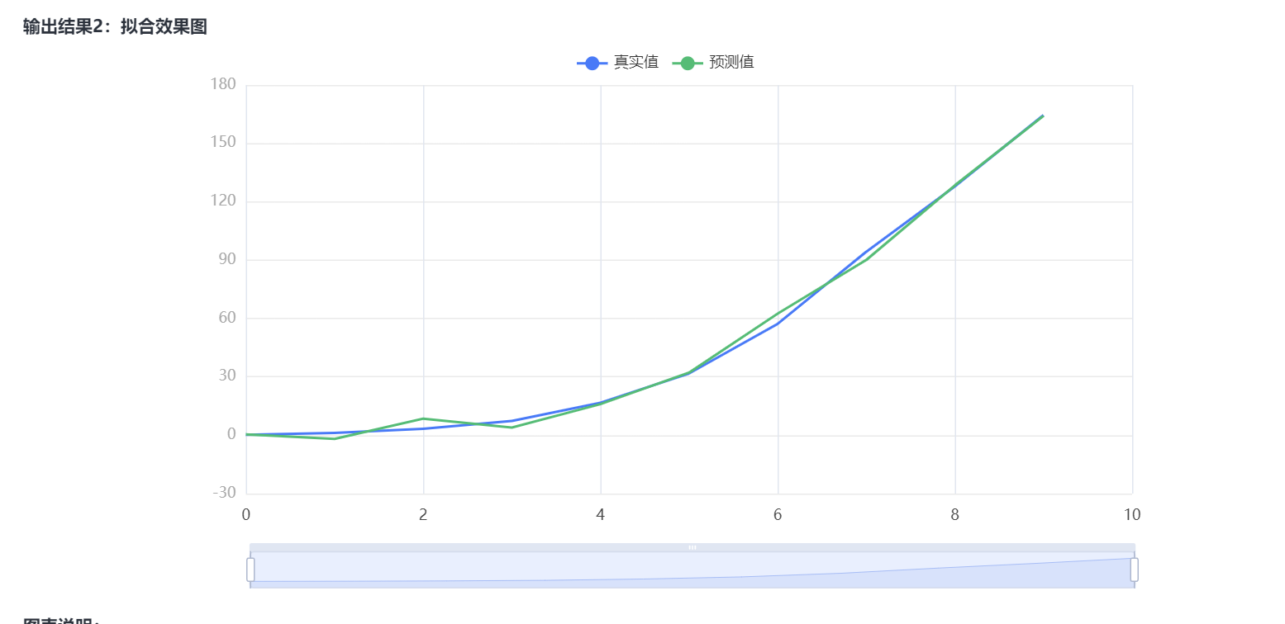

Based on the resultant fit we know that the predicted value of New energy vehicle ownership (10,000 vehicles) is very close to the true value and the fit is successful.

1. **New Energy Vehicle Market Size (RMB billion) multiple regression curve**

**In the same way as above, we can obtain a set of equations：**

New Energy Vehicle Market Size (RMB billion)=-0.569-6.291（Year）-1.893*（Number of patent applications for new energy vehicles (items)）+28.455*（Amount of subsidies for new energy vehicles (RMB billion)）+0.344（Total carbon emissions (millions of tons)）-5.866*（Lithium iron phosphate power battery installed capacity/GWh）+16.201*（Installed capacity of ternary battery/GWh）+559.405*（Weighted average price of new energy vehicles ($10,000)）

1. **Analyzing and summarizing the first question**

In general, government subsidies, total carbon emissions, installed capacity of ternary batteries, and the weighted average price of new energy vehicles have a positive impact on the market size, while the number of patent applications and the installed capacity of lithium iron phosphate power batteries have a negative impact.

However, from my perspective, an increase in the number of patent applications may signify the growing applicability of patents to new energy vehicles. Additionally, as the development of lithium iron phosphate power batteries matures, it is likely to have a positive impact on the market size. We recognize that during the initial stages of technological development, significant investments are required, and any short-term negative impacts may be inconsequential. Following our group research, a consensus has emerged that these factors will likely contribute positively to the new energy vehicle market in the future.

Therefore, it is conceivable that a higher number of patent applications could reflect increased technological relevance to new energy vehicles, and the mature development of lithium iron phosphate power batteries may eventually contribute positively to the market size. As our group collectively believes, these factors are expected to benefit the new energy vehicle market substantially in the future.

**5.2 Predicting the future development of new energy electric vehicles in China in the next 10 years.**

(1)**Preliminary trend of increase/decrease based on sales graphs**

The sales of new energy vehicles year by year according to the year - sales plotted as the following curve, from which we can see that the sales of new energy vehicles and the year between the year does have a rising trend, and we can see that the sales of new energy vehicles in the initial emergence of the trend of low-frequency slow growth in about 2013, and in 2020 after the trend of high rate of growth, the analysis of the world's new energy science and technology and the Chinese government's new energy vehicle policy support and other factors, to be discussed in the follow-up.

**Picture Year vs. graph Production and sales of new energy vehicles (10,000 units)**

After the sales of new energy vehicles are processed by the first-order difference, the obtained first-order difference-year graph shows an exponential growth trend, which generally shows a relatively smooth first and a rapid growth trend until the beginning of 2020. Overall it is still in the form of growth.

**Picture first-order difference in value Production and sales of new energy vehicles**

1. **Modeling based on multiple regression linear curves**
2. Combining examples and research, we can find that the change of annual sales of new energy vehicles is related to Year、New energy vehicle ownership (10,000 vehicles)、New Energy Vehicle Market Size (RMB billion)、New energy vehicle market penetration (%)、New Energy Vehicle YoY Growth Rate (%)、Number of new energy vehicle enterprises (number)、Number of patent applications for new energy vehicles (items)、Scale of new energy vehicle industry chain (home)、Number of charging piles for new energy vehicles (10,000)、Coverage of new energy vehicle charging infrastructure (%)、Amount of subsidies for new energy vehicles (RMB billion)、Market penetration of conventional fuel vehicles (%)、Total carbon emissions in the Yangtze River Delta region (million tons)、Production and sales of conventional vehicles (10,000 units)、Conventional Vehicles YoY Growth Rate (%)、Lithium iron phosphate power battery installed capacity/GWh、Installed capacity of ternary battery/GWh、Total carbon emissions (millions of tons)、Weighted average price of new energy vehicles ($10,000)and other variable factors are closely related.

Therefore, we will model the relationship between Production and sales of new energy vehicles (10,000 units) and the other 19 independent variables based on the collected dataset.And the model's conclusions are used to predict the development of new energy electric vehicles in China over the next decade.

⚫ Build multiple linear models

We order:

*x*1=Year

*x*2=New energy vehicle ownership (10,000 vehicles)

*x*3=New Energy Vehicle Market Size (RMB billion)

*x*4=New energy vehicle market penetration (%)

*x*5=New Energy Vehicle YoY Growth Rate (%)

*x*6=Number of new energy vehicle enterprises (number)

*x*7=Number of patent applications for new energy vehicles (items)

*x*8=Scale of new energy vehicle industry chain (home)

*x*9=Number of charging piles for new energy vehicles (10,000)

*x*10=Coverage of new energy vehicle charging infrastructure (%)

*x*11=Amount of subsidies for new energy vehicles (RMB billion)

*x*12=Market penetration of conventional fuel vehicles (%)

*x*13=Total carbon emissions in the Yangtze River Delta region (million tons)

*x*14=Production and sales of conventional vehicles (10,000 units)

*x*15=Conventional Vehicles YoY Growth Rate (%)

*x*16=Lithium iron phosphate power battery installed capacity/GWh

*x*17=Installed capacity of ternary battery/GWh

*x*18=Total carbon emissions (millions of tons)

*x*19=Weighted average price of new energy vehicles ($10,000)

y=β0+β1*x*1+β2*x*2+β3*x*3+β4*x*4+β5*x*5+β6*x*6+β7*x*7+β8*x*8+β9*x*9+β10*x*10+β11*x*11+β12*x*12+β13*x*13+β14*x*14+β15*x*15+β16*x*16+β17*x*17+β18*x*18+β19*x*19 **(1)**

Using the python code for the multiple regression algorithm (Appendix 1), we can get the value of this multiple regression equation as:

y=-175.361921+0.786334*x*1+4.674333*x*2+0.133171*x*3+1.340155*x*4+0.203066*x*5+5.114536*x*6-1.460884*x*7+0.602279*x*8+2.367206*x*9-7.039104*x*10+7.524213*x*11-1.340155*x*12-0.623688*x*13+0.488335*x*14-6.786688*x*15-2.279974*x*16+5.143792*x*17-0.075757*x*18+0.393167*x*19 **(2)**

**Table Model Summary**

|  |  |  |  |
| --- | --- | --- | --- |
| Model | R | R square | Adjust R square |
|  | 0.930 | 0.865 | 0.980 |

According to the multiple regression model it is shown that the model R is 0.930, the square of R is 0.865 and the adjusted R square value is 0.980, which indicates a very good fit.

Hypothesis is raised in F-test: all coefficients are 0. From the ANOVA table (see appendix), it can be seen that the p value of the F test is <0.001, and the null hypothesis is rejected at the significance level of 0.05, and the test is passed.

We substituted formulas to calculate projected annual sales based on the values of the other nineteen formulas (the algorithm is attached in the Appendix), and then calculated a graph of year-annual sales - projected sales as follows.

**picture imagery of year-annual sales - projected sales**

From the above figure, we can find that the number of expected annual sales and the actual number of annual sales is really too close, leading to the fact that we may wonder whether there is a second line drawn, so we do not put a different way of thinking, to make the number of expected annual sales - the actual number of annual sales of the x-y curve, we can clearly see that the slope of the image k = 1, and the intercept is only -0.0046, which is very small, so you can approximate that the predicted results are exactly the same as the actual results. The fit is valid.

**Picture Forecasted - Actuall Number of units sold**

From the graph I gave and the formula new energy vehicle production and sales (10,000 units) = -175.361921 + 0.786334 × year + 4.674333 × new energy vehicle ownership (10,000 units) + 0.133171 × new energy vehicle market size (100 million yuan) + 1.340155 × new energy vehicle market penetration rate (%) + 0.203066 × new energy vehicle vehicle chain growth rate (%) +5.114536×number of new energy vehicle enterprises (home) +-1.460884×number of new energy vehicle patent applications (item) +0.602279×size of new energy vehicle industry chain (home) +2.367206×number of new energy vehicle charging piles (10,000 pcs) +-7.039104×coverage of new energy vehicle charging infrastructure ( %) + 7.524213 × amount of subsidies for new energy vehicles (RMB 100 million) + -1.340155 × market penetration rate of traditional fuel vehicles (%) + -0.623688 × total carbon emissions in the Yangtze River Delta region (millions of tons) + 0.488335 × production and sales volume of traditional vehicles (10,000 vehicles) + -6.786688 × chain growth rate of traditional vehicles (%) + - 2.279974×Lithium iron phosphate power battery installed volume/GWh+5.143792×Ternary battery installed volume/GWh+- can be known.

1. New energy vehicle production and sales (10,000 units) and year, new energy vehicle ownership (10,000 units), new energy vehicle market size (RMB 100 million), new energy vehicle market penetration rate (%), new energy vehicle chain growth rate (%), number of new energy vehicle enterprises (home), new energy vehicle industry chain size (home) new energy vehicle industry chain size (home), number of new energy vehicle charging piles (10,000) The independent variables of new energy vehicle subsidy amount (RMB 100 million), installed capacity of ternary batteries/GWh, and weighted average price of new energy vehicles (RMB 10,000) are positively correlated.

2. Negative correlation with total carbon emissions (million tons), chain growth rate of conventional vehicles (%), etc.

From the following change curves of the respective variables, it can be seen that the total sales volume of new energy vehicles (10,000 units) will grow exponentially in the next ten years.

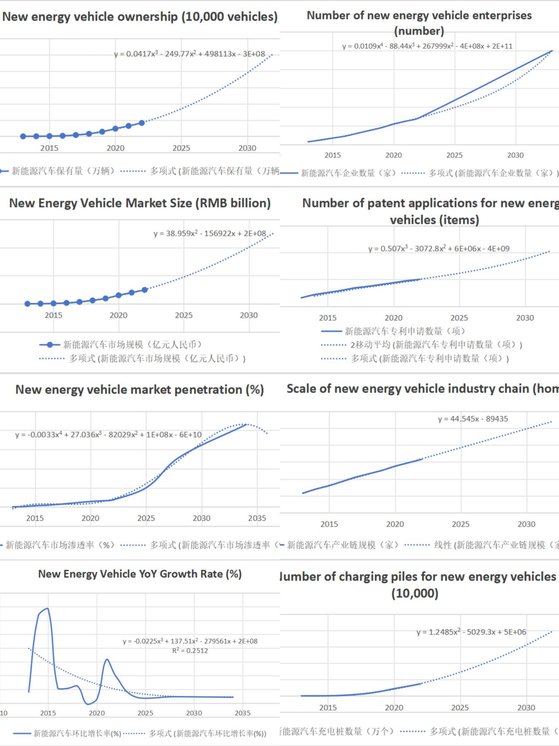

**Picture The variation curve of each variable over the year（1）**

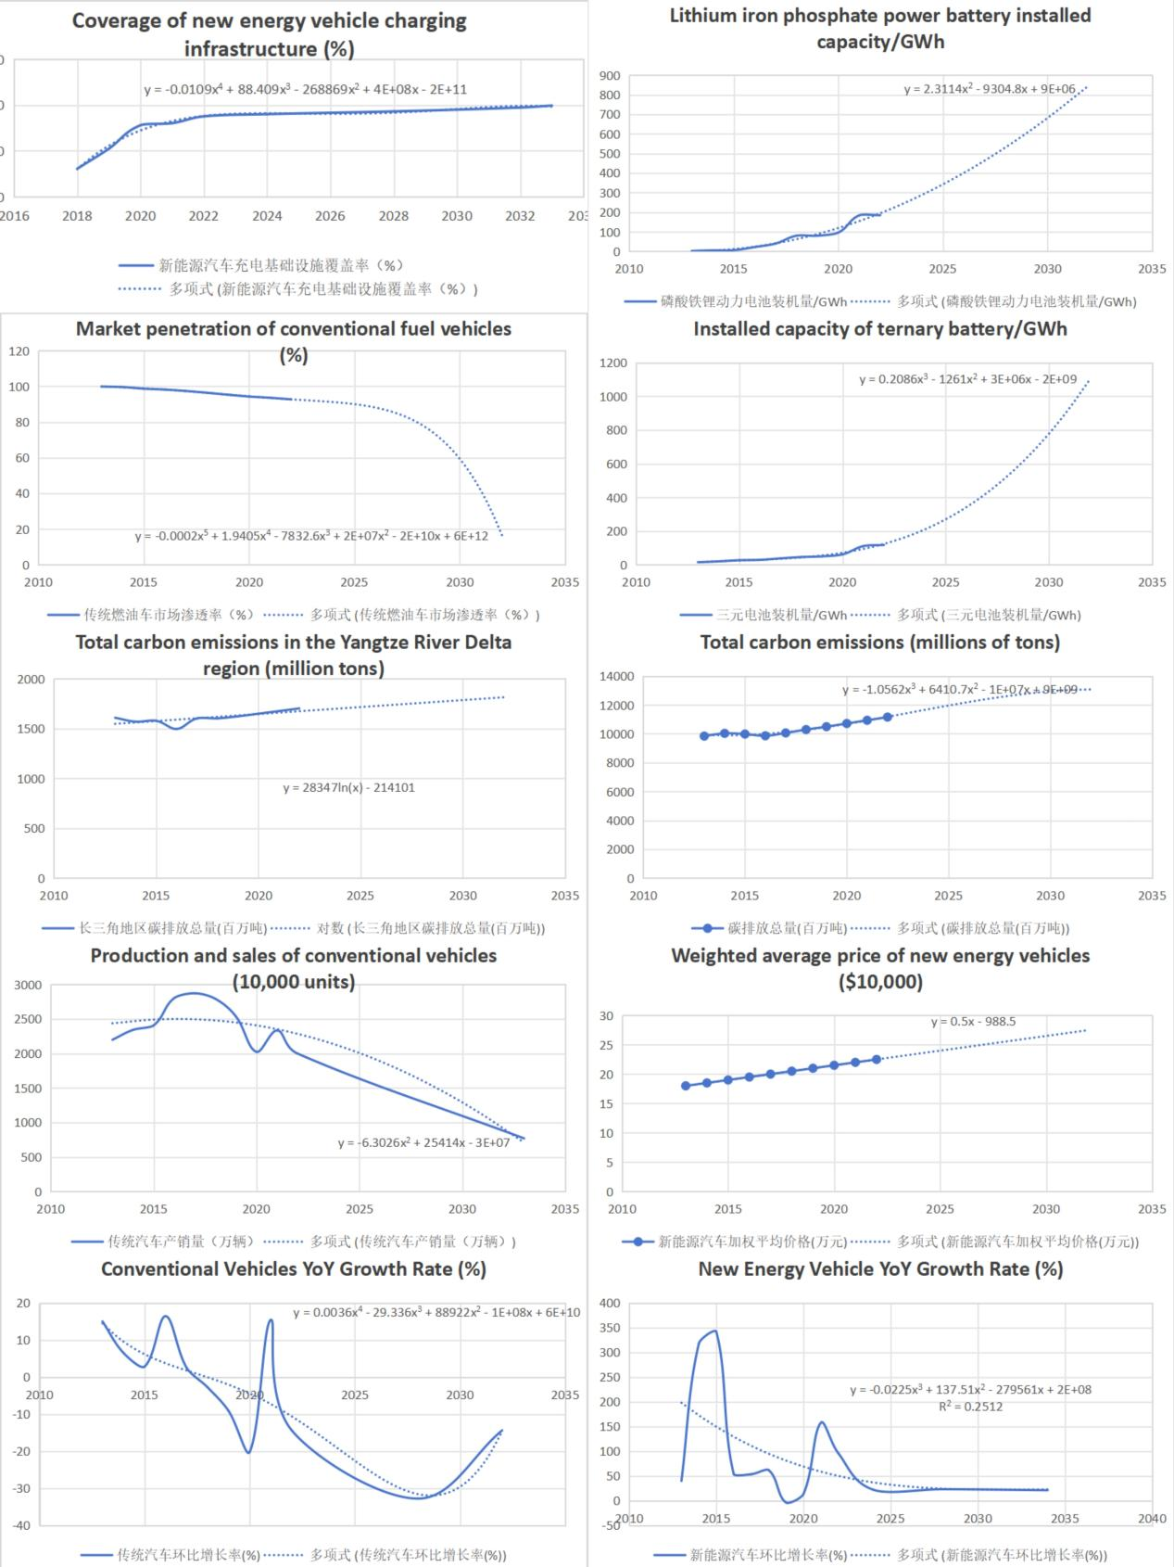

**Picture The variation curve of each variable over the year（2）**

In summary, I have the following views on the development of new energy vehicles in China in the next decade:

1. In the next decade, the number of new energy vehicles (10000 units) will steadily increase, currently showing a cubic growth, and will continue to grow until reaching a certain order of magnitude and starting to grow steadily and slowly.

2. The scale of the new energy vehicle market (in billions of RMB) will be greatly increased, gradually surpassing the sharp decline in the traditional vehicle market size with increasing derivatives

3. The penetration rate (%) of the new energy vehicle market will gradually increase, ultimately reaching over 70%.

4. The month on month growth rate (%) of new energy vehicles will first increase and then decrease. As the month on month growth is compared to the previous year's growth, the growth rate will not be particularly high in the future, but overall it still shows a growth trend.

5. The number of new energy vehicle enterprises will increase. As new energy vehicles are an emerging market, manufacturers such as Tesla will make a lot of money, which will attract more manufacturers to enter new energy. At present, the most representative manufacturers are Huawei's Wenjie and Xiaomi Motors.

The number of patent applications for new energy vehicles will gradually increase, and then gradually decrease. Due to the current peak period of new energy vehicle development, it is normal for patents to spring up one after another. As the new energy industry gradually matures in the future, the number of patents will decrease.

7. The scale of the new energy vehicle industry chain will gradually increase, consistent with the conclusion in 5

The number of new energy vehicle charging stations (10000) will be significantly increased to adapt to the increasing holdings of new energy vehicles and attract new customers.

9. The coverage rate (%) of new energy vehicle charging infrastructure will be significantly increased, for the same reason.

The most important thing is that the sales of new energy vehicles will also steadily increase. In short, the development of new energy electric vehicles in China in the next 10 years will be very promising, and the future is bound to be limitless!

**5.3 Collect data and establish a mathematical model to analyze the impact of new energy electric vehicles on the global traditional energy vehicle industry.**

### Data Preparation and Preprocessing:

### Data Organization: Transform raw data into an analyzable format, ensuring correct data types for each variable (e.g., years as date format, sales volumes as numerical values).

### Missing Values: Inspect the dataset for any missing entries. If present, choose to impute (using methods like mean of neighboring values, median, or regression prediction based on other variables) or to exclude missing records.

### Outlier Analysis: Identify and scrutinize outliers to determine whether they result from input errors or natural fluctuations. Correct or exclude errors; retain natural fluctuations as they may represent real-world scenarios.

### Normalization/Standardization: Apply normalization or standardization techniques (such as Z-score standardization) to adjust the scale of data, eliminating the influence of different variable magnitudes.

### Exploratory Data Analysis (EDA):

### Time Series Analysis: Plot time series for each variable to observe trends and patterns over time, identifying any evident trends or seasonality.

### Scatter Plot Analysis: Create scatter plots to explore relationships between variables, such as the relationship between electric vehicle sales and crude oil prices.

### Correlation Matrix Visualization: Construct a correlation matrix and visualize it to discern linear relationships between variables, aiding in variable selection for the VAR model.

### Correlation Analysis:

### Pearson Correlation Coefficient: Compute the Pearson correlation coefficient between electric vehicle sales, traditional vehicle sales, and crude oil prices to quantitatively describe their linear relationships.

### Significance Testing: Perform tests to ascertain the statistical significance of the correlation coefficients, thus determining the reliability of the relationships between variables.

### Causality Testing:

### Granger Causality Test: Conduct Granger causality tests to determine if one variable's historical values can significantly predict future values of another, thereby establishing a Granger cause.

### Lag Selection: Choose the number of lags to use in Granger causality testing, typically selected based on information criteria such as AIC or BIC.

### VAR Model Construction:

### Variable Selection: Based on EDA and correlation analysis outcomes, select appropriate variables for the VAR model.

### Model Estimation: Estimate the VAR model's parameters using the ordinary least squares method.

### Lag Structure Determination: Determine the optimal lag order for the VAR model using information criteria.

### Model Estimation and Testing:

### Model Diagnostics: Conduct diagnostic tests, including tests for autocorrelation of residuals, heteroscedasticity, and model stability.

### Predictive Accuracy: Assess the model's predictive accuracy, often by reserving a portion of data as a test set.

### Model Interpretation and Policy Analysis:

### Impact Interpretation: Interpret the results of the VAR model, discussing how the growth in electric vehicle sales dynamically influences the sales of traditional energy vehicles.

### Policy Impact Discussion: Explore how electric vehicle-related policies might affect the relationships between these variables and how policymakers can utilize these findings.

### External Factors Consideration: Discuss potential external factors that may impact the markets for electric vehicles and traditional energy vehicles, and how these factors might be incorporated into future research.

### Translated Conclusions:

### The data indicates that the market share of electric vehicles grew from 0.4% in 2013 to 18.6% in 2022, a substantial increase that correlates with a decline in traditional energy vehicle sales. Specifically, as electric vehicle sales have risen, traditional vehicle sales have demonstrated a downward trend. This suggests a shift in consumer preferences and the impact of reduced costs and technological advancements in electric vehicles, attracting more buyers.

### The increase in the electric vehicle market share significantly correlates with a decrease in the average fuel consumption of traditional vehicles. This suggests that automobile manufacturers may be enhancing the fuel efficiency of traditional vehicles to compete with electric vehicles, or consumers may be increasingly opting for models with lower fuel consumption.

### While the growth in electric vehicle market share has not directly impacted crude oil prices (the correlation is not significant), it does not preclude the potential for long-term effects on the energy market. As electric vehicle costs continue to decrease and policies further support, the demand for traditional fuel vehicles might decline, potentially affecting future crude oil demand and prices.

### In conclusion, the emergence of electric vehicles is gradually impacting the global traditional energy vehicle industry. Specifically, with the continuing expansion of the electric vehicle market share, global sales of traditional vehicles have begun to be affected, as indicated by decreasing sales. Meanwhile, the traditional vehicle industry's technological adaptation is reflected in improved fuel efficiency and reduced consumption. However, so far, the rise in the electric vehicle market has not had a significant impact on crude oil prices, which may be due to the crude oil market being influenced by a variety of factors, including global economic activity levels, international political situations, and the development of alternative energy markets.

**5.6 Based on the conclusion of question 5, write an open letter to the citizens to publicize the benefits of new energy electric vehicles and the contributions of the electric vehicle industry in various countries around the world.**

Dear Citizens,

In our journey towards a sustainable future, the emergence and expansion of new energy electric vehicles (EVs) stand as a testament to our collective commitment to environmental stewardship and technological innovation. These vehicles, characterized by their minimal environmental footprint, are pivotal in reducing urban pollution and enhancing air quality. Unlike their traditional counterparts, EVs convert energy with remarkable efficiency, offering a sustainable alternative that aligns with the global imperative to conserve resources.

In addition to their environmental benefits, electric vehicles are driving technological advancements across multiple sectors, including battery technology, smart connectivity, and autonomous driving systems. This evolution is not just a leap in vehicular technology but a catalyst for broader socio-economic changes. Economically, EVs present a cost-effective solution for consumers, promising lower long-term operating and maintenance expenses.

Globally, countries have been contributing significantly to this transformative movement. China, for instance, has solidified its position as a leader in the EV market, boasting record-breaking sales and a rapidly increasing market penetration. The Chinese government's robust policies under its dual carbon goals have been instrumental in catalyzing this growth, demonstrating a commitment to high-quality industry development. Concurrently, the United States has embarked on an ambitious plan to integrate EVs into its national fabric. With strategic investments in infrastructure and manufacturing, driven by comprehensive legislative support like the Bipartisan Infrastructure Law and the Inflation Reduction Act, the U.S. is poised to significantly influence the global EV landscape.

Similarly, the European Union's initiatives have been pivotal in driving EV adoption. By implementing stringent CO2 emission standards, the EU has not only promoted environmentally friendly vehicles but also spurred innovation in green technologies. The collaborative efforts of European nations in policy formulation and infrastructure development further underline a shared vision for a green and sustainable future.

As we embrace this era of electric vehicles, it is evident that our choices transcend beyond individual preferences to a collective responsibility towards a greener, more efficient, and sustainable world. The commitment and actions of countries like China, the United States, and the European Union reflect a global paradigm shift, one where the adoption of electric vehicles is a key component in our pursuit of environmental sustainability and economic resilience.

In closing, the journey towards a sustainable future is not a solitary endeavor but a collaborative effort that requires the participation and support of each one of us. As we continue to witness and contribute to this transformation, let us remember that each step towards embracing electric vehicles is a step towards a cleaner and more sustainable world.

Sincerely